Name:
Student ID:
Signature:
THE UNIVERSITY OF NEW SOUTH WALES
School of Electrical Engineering and Telecommunications
ELEC2133: Analogue Electronics
FINAL EXAMINATION
Term 2, 2023
Reading time: 10 minutes
Time allowed: 2 hours
Total marks: 100
Total number of questions: 3
This exam contributes to 50% of the total assessment of this course.
The exam contains three questions and has nine pages.
Part marks for all questions are indicated.
The candidates must attempt all the questions.
The exam paper must not be retained by the candidate and returned with the booklets.
Use separate answer booklets for each question.
The examination is closed book.
The candidates are allowed to bring UNSW approved calculators.
Assumptions made in answering the questions must be stated explicitly.
All answers must be written in inks, except where they are expressly required to use pencil for drawing, sketching, or graphical work.

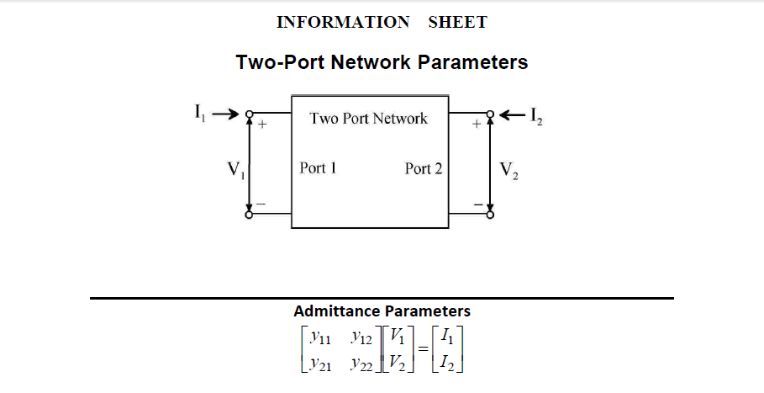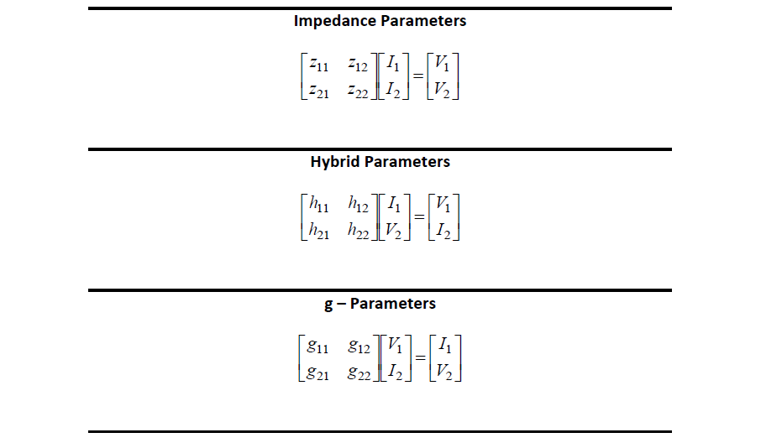

QUESTION 1 [25 marks]
- A monostable multivibrator circuit is shown in Fig. 1(a). The circuit can be triggered by applying a narrow positive input pulse of height greater than V_{ref}. For normal operation, C₁R₁<< CR. The saturation voltages of the op-amp are V_{L} and –V_{L}.
Fig. 1 (a): Monostable multivibrator

- In the stable state, what are the values of V_{o}, V_{A}, and V_{B} [3 marks]
- Show the resulting waveforms of V_{o} and V_{A} after the circuit has been triggered.
[4 marks]
- Show that the pulse generated at the output will have a width T given by
$T=CRln\left(\frac{2V_{L}}{V_{ref}}\right)$ [6 marks]

- The ladder type of Digital-to-Analogue converter (DAC) is shown in Fig. 2(b). The blocks labelled S_{i} represents a switch that connects to V_{ref} when the bit a_{i}=1 and ground when the bit a_{i}=0. Calculate the output voltage, V_{o}, assuming an 8-bit DAC and a binary word of (10010011), R₂ = 100kΩ, R₁ = 10kΩ, R = 10kΩ and V_{ref} =6V.
[6 marks]
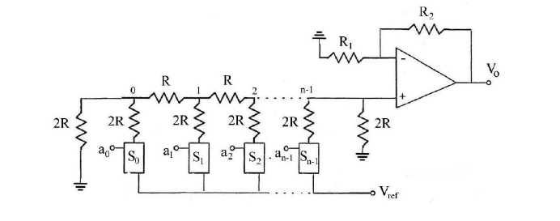
Fig. 1 (b): Ladder type DAC

- Assume the op-amp used in the ladder type of Digital-to-Analogue converter (DAC) shown in Fig. 1 (b) has DC imperfections and shows offset error as a result.

  - Find the expression for the offset voltage of the DAC in terms of R₁, R₂ and R. Assume the input bias currents are I_{B+} and I_{B-}, and the input offset voltage V_{io}. [4 marks]

  - Based on your expression in (i), what value of R would you choose to minimize the offset?
[2 marks]

QUESTION 2 [35 marks]
- Four amplifier circuits are shown in Fig. 2(a)-(d). The amplifiers are biased by a current source established by a MOSFET current mirror pair Q3 and Q4. Transistor aspect ratios (W/L) of the MOSFETs are indicated in the figure. Details of small signal model parameters are given in the information sheet on page 3.
(a) (b)
(c) (d)
Fig. 2(a) –(d): Amplifier Circuits
- Identify the configuration of each of the transistors in the amplifiers in Fig. 2(a)-(d).
[2 marks]
- Compare the amplifier circuits above in terms of gain, bandwidth, and output impedance without doing calculations and provide justification for your comparison. [4 marks]

- A differential amplifier circuit is shown in Fig. 2 (e). The amplifier is biased by a current source established by a BJT current mirror pair Q3 and Q4. Details of small signal model parameters for the transistors are given in the information sheet on page 3.
Fig. 2(e): Differential amplifier circuits
- Determine the current in the current source established by the BJT current mirror in the differential amplifier shown in Fig. 2(e). [3 marks]
- Determine the DC biasing current in Q₁ and Q₂ in Fig. 2(e). [2 marks]
- Calculate the g_{m1} r_{π1} of Q1 and g_{m2}, r_{π2} of Q₂ in Fig. 2(e). [2 marks]
- Calculate the DC voltages at nodes w, x, y and z. Show that transistor Q₁ and Q₂ in Fig. 2(e) are operating in the forward active regions, respectively. [5 marks]
- Calculate the gain of the amplifier (assuming the differential amplifier in Fig. 2(e) single ended – output either at Y or Z). [5 marks]
- Calculate the high cut-off frequency (f_{H}) of the differential amplifier in Fig 2(e). [7 marks]
- Comment on the possible values of resistors that may replace 7k to ensure that the differential amplifier in Fig. 2(e) is biased appropriately. [ Note: for amplifier operation, all BJTs must operating in the forward active regions]
[5 marks]

QUESTION 3 [40 marks]
The amplifier circuit in Fig. 2(e) is now modified with feedback as shown in Fig. 3 (a). An external capacitor, C_{m}, is added at the output of the differential amplifier, which is applied to a difference amplifier for further amplification before the output of the circuit is fed back to the input. For this question, assume that the op-amp in the difference amplifier as ideal.
Fig. 3 (a): Amplifier with feedback

- Identify the type of feedback topology employed in the amplifier. [5 marks]

- Identify and determine the β of the feedback network. [5 marks]

- Draw the open loop amplifier circuit considering the loading effect of the feedback networks. [5 marks]

- Calculate the mid-band open loop voltage gain of the amplifier. [6 marks]
- Determine the closed-loop mid-band gain of the amplifier. [4 marks]

- Calculate the output (R_{out}) and input (R_{in}) resistances of the closed-loop amplifier at midband.
[5 marks]

- Calculate the f_{H} of the feedback amplifier. [4 marks]

- Now the feedback amplifier in Fig. 3 (a) is modified to Fig. 3 (b) by connecting Y and Z to the different input terminals of the difference amplifier, comment on how the gain, bandwidth, input and output resistances may be affected? [6 marks]

Fig. 3 (b): Amplifier with feedback

END OF EXAMINATION

